Table of Contents

Introduction (Section 1) 2

Project Overview and Justification

Aims and Objectives

Website Design (Section 2) 3-7

Flowcharts

Interface design

Website Implementation (Section 2) 8-20

Main page

Location pages

JavaScript algorithms

Results and Discussion (Section 3) 21

Testing

Conclusion and Further Work (Section 3) 22

Conclusion

Improvements

**Introduction**

**Project Overview**

The real estate industry is one of the largest industries in the UK, valued at $1.7 Trillion the industry is going through a period of accelerated growth, (*Real estate market in the UK - statistics & facts* 2023). This growth has led to a requirement for the efficient marketing of properties, web technologies can help to achieve this. Web technologies are used throughout the world, today the web industry has over 5 Billion users worldwide, a number predicted to increase, (Vardhman & Ivanov, 2023).

Guided by user feedback and testing, a website will be developed using CSS, HTML and JavaScript. This website will market differing properties offering customers useful information such as contact information, cost, locations, and benefits.

**Aims and Objectives**

The website design is important, it can influence customers greatly, therefore, the site must be aesthetically pleasing providing relevant detailed information.

**Aims**

* The website is aesthetically pleasing.
* Relevant helpful information is displayed.
* The site is accessible.
* It is easy to find relevant information.
* The website is responsive.
* Users can enquire using the site.

**Website Design**

The website will be designed using CSS, HTML and JavaScript, supported by a range of browsers these languages provide the structure, styling and interaction of the site. The website will be designed within this section, adhering to the aims and objectives outlined above.

**Flowcharts**

This flowchart follows the steps users would take to view differing parts of the site, this design method provides clarity, allowing the interface to be adapted ensuring accessibility and ease of use.

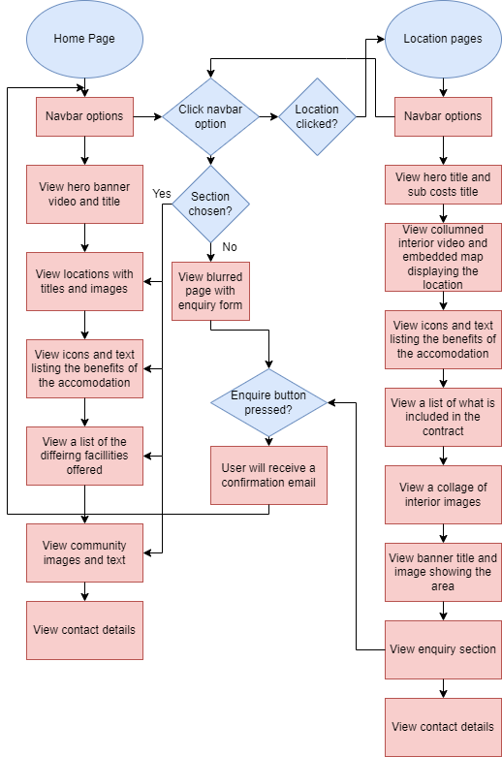**Figure .1** User flowchart detailing the process users follow on the site.

**Figure 2.** Flowcharts detailing the flow of execution within the JavaScript program.

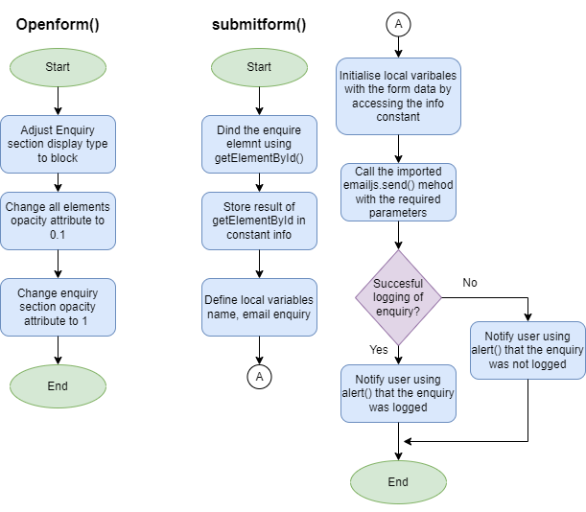

**Interface Design**

This interface design is based on similar sites, as familiarity increases the intuitiveness of an Interface (Raskin, 1994). The font family used throughout the site is “Poppins”, this font increases the interface's readability due to its prevalence across the web and its spaced soft characteristics (Tullis et al., 1995).

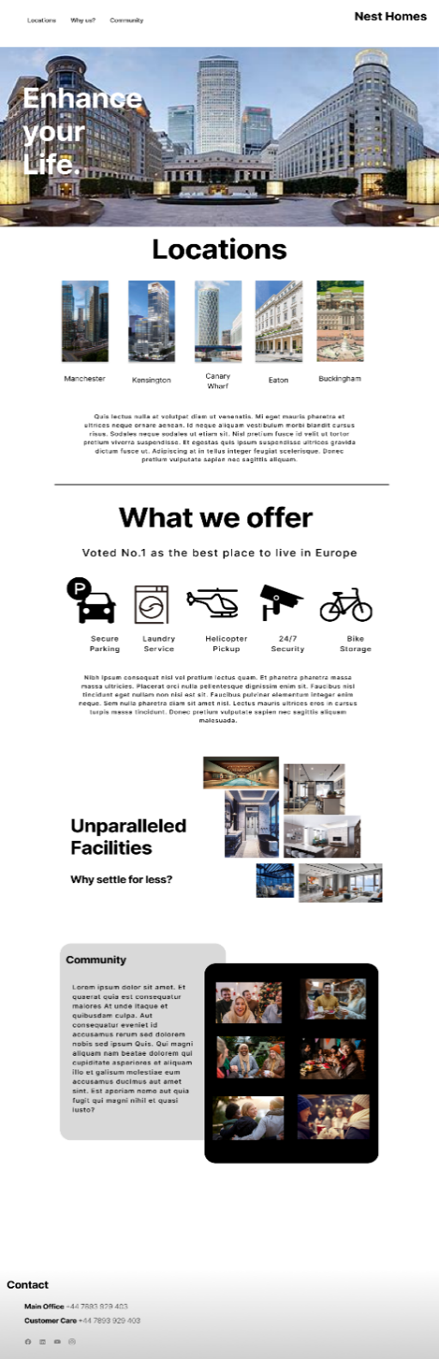**Figure 3.** Initial design of website landing interface

This interface design contains the information typically required for real estate sites (Team, 2021):

* Location
* Contact information.
* Facilities
* Benefits

This page acts as a landing page, advertising the accommodation and prompting them to further explore the company's services by clicking on the different links. The page will contain many links that can be used to navigate to differing pages and sections, increasing usability. This page will also contain interactive elements to highlight key aspects and information to the user such as; awards, contact information and images.

A single style sheet was used for the differing HTML location pages increasing the site’s efficiency. The pages differ slightly, displaying relevant information about each location.

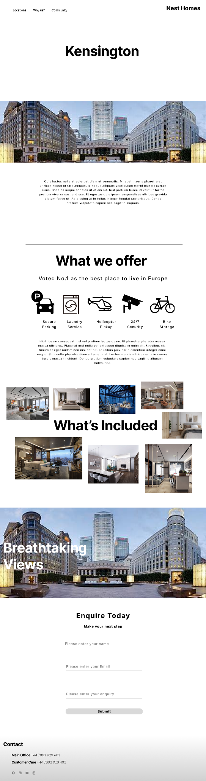**Figure 4.** Initial design of website location pages

**Website Implementation**

The website has been implemented using HTML, CSS and JavaScript, these languages are incredibly portable and efficient allowing the site to be styled to design specifications across a range of devices (Yadav & Barwal, 2014).

On average internet users spend 60% of their web browsing time on their mobile devices, therefore, considerations for differing devices have been made, the website has been made responsive to accommodate for all screen types (Ceci, 2024)

**Main Page**

This page is the main page designed to sell the accommodation and display the services provided, it also offers the user easy navigation to other pages via the navbar.

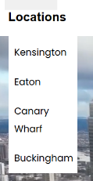**Figure 5.** Navbar of the main page

The page navbar uses an inline-styled list containing differing HTML elements including; images, anchors (links) and buttons. These elements are styled with a bold font weight and evenly spaced using the CSS padding attribute.

Hovering over the “location” anchor tag will display a dropdown menu containing location page links, this menu improves accessibility and ease of use, by making it easier to navigate to specific areas quickly.

Differing from the initial design, the company's logo has been displayed in the navbar using an image and anchor tag, when clicked the user will be navigated back to the main page.

Navbar anchor tags will scroll smoothly to that part of the page using element IDs as directives regardless of the current page.

**HTML**

<li><a class="Community" href="#CommunityColumn1" id="sign-up"><h3>Community</h3></a></li>

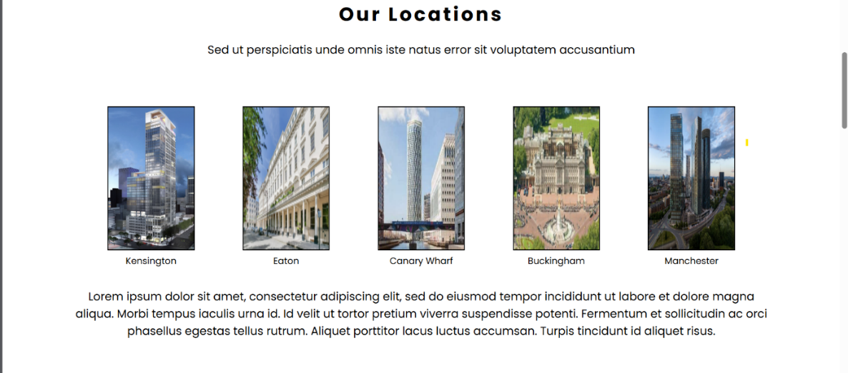**Figure 6.** The location section of the main page

This part of the page is responsible for displaying the differing locations available for purchase, these are displayed as image tags within anchor tags therefore can be interacted with. Once clicked the images will direct the user to the respective pages using anchor tags changing the directory.

**HTML**

<figure>

        <a href= "Kensington.html"> <img id="Kensington" src="Kensington.jpg" alt="Web-Logo" width="150px" height="250x"></a> *<!--https://www.skyscrapercenter.com/building/kensington-tower/36304-->*

        <figcaption>Kensington</figcaption>

      </figure>

Initially, the “figure” element was not used, instead, captions were styled to match the image's position, this method proved ineffective during responsiveness testing. Fig caption elements shrink in size together maintaining their readability regardless of screen type.

**Figure 7.** The benefits section of the main page

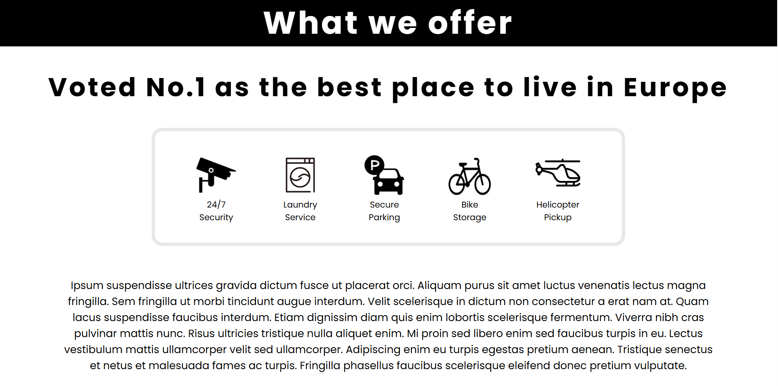

This section details accommodation benefits in a simplistic readable format, working similarly to the location section, icons are displayed using the caption element and styled with an inline display.

Icon interpretation is subjective to culture, captioning the icons ensures the intended interpretation and improves readability and accessibility (Knight et al., 2009).

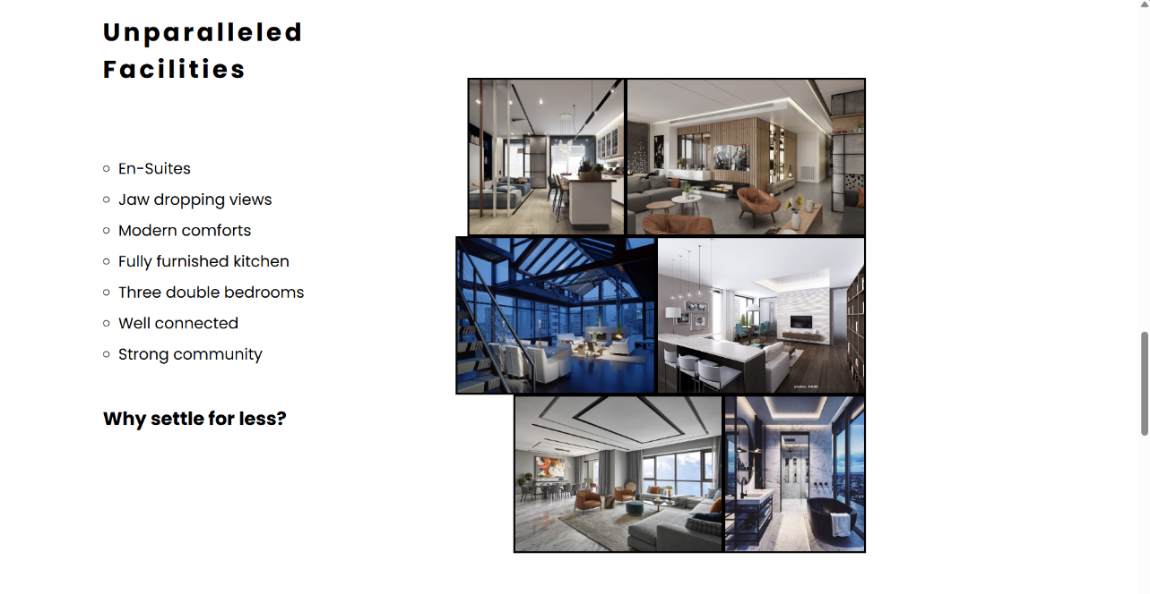**Figure 8.** The benefits section of the main page

This section details the accommodation facilities, the page is split into two columns displaying an unordered list on the left and a collage on the right. Splitting the page saves space increases ease of use and reduces webpage resource requirements.

This design lacked responsiveness with elements being pushed to the side and out of view, reducing the site's readability, therefore, the collage has been styled to have no overflow removing images that are too big for the screen. The right column will always float to the right maintaining its position regardless of screen size, helping to improve readability.

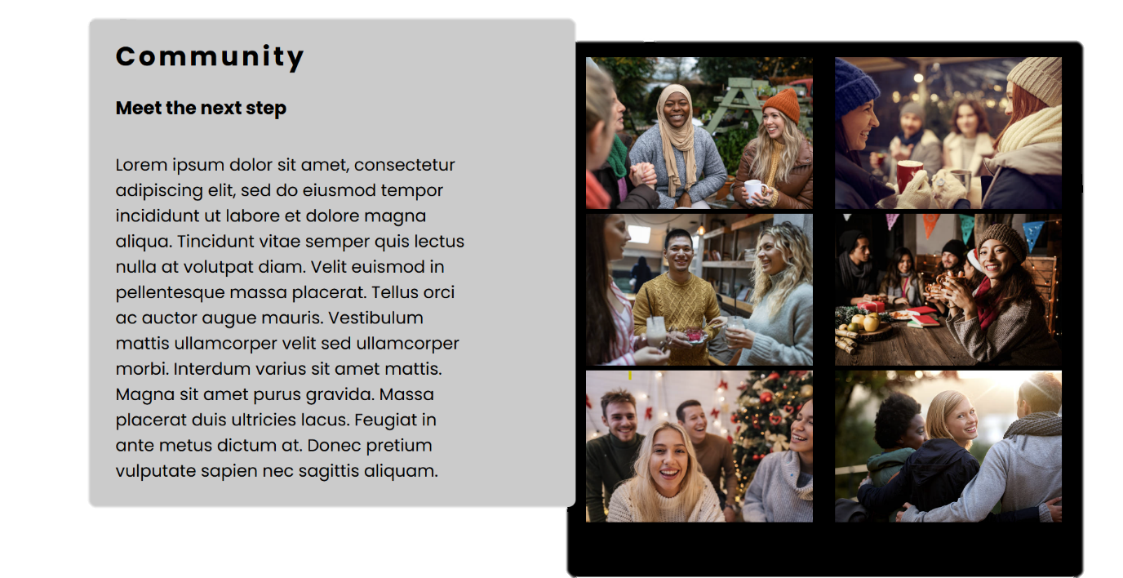**Figure 9.** The main page’s community section

This section of the page displays the community aspect of the accommodation, community is one of the biggest factors considered when buying accommodation (Hassan et al., 2021). Like the benefit section, this part of the page is split into two columns, these columns are padded and coloured with contrasting colours to improve readability.

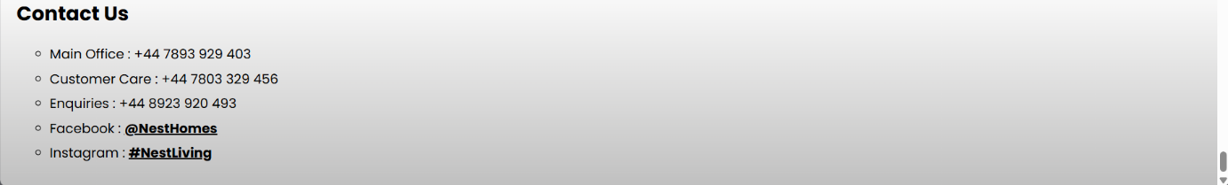**Figure 10.** Contact section of the website

Duplicated across all pages on the site, this section displays the company contact details using an unordered list, key information has differing font weights improving site accessibility and ease of use.

**Location Pages**

These pages are very similar, allowing the use of one cascading style sheet to improve site efficiency and script readability.

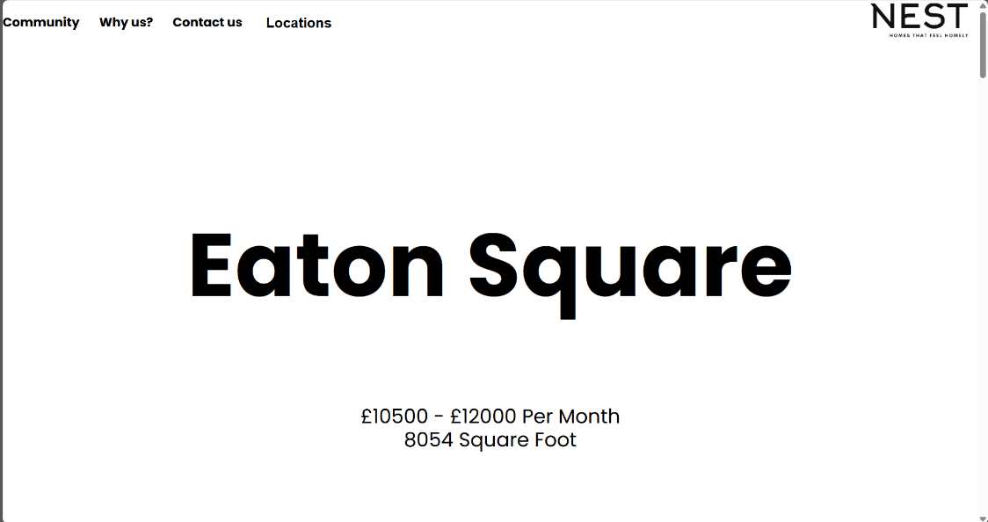**Figure 11.** Location pages hero title and subtitle

The user will first be greeted with a hero banner and subtitle displaying key information such as the cost, size and location. The banner has a 100% width while the font size is based on the viewport width determined by screen width.

**Figure 12.** Location pages video and embedded map

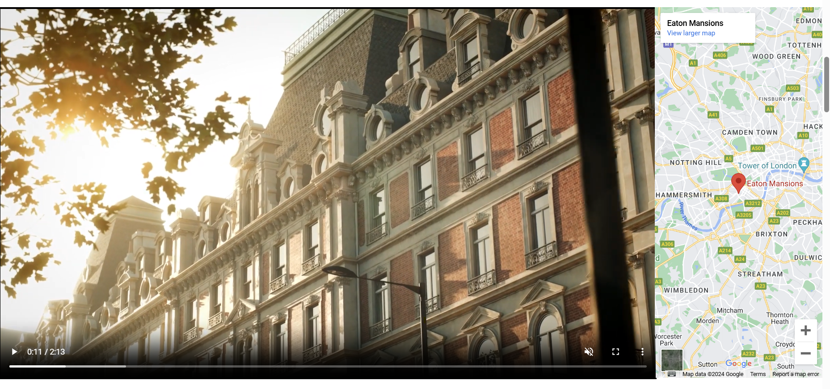Like the above section, the user will be greeted with a full-width display. This display contains a video and an embedded Google map showing the accommodation’s interior and location.

**HTML**

<div class = "Overview">

    <video  class = "Interiorvid" width = "50%" height = "10%" muted controls autoplay loop> *<!--https://youtu.be/GJ9BkblyfWg-->*

        <source src="KensingtonInterior.mp4" type="video/mp4">

    </video>

    <iframe class = "Map" src="https://www.google.com/maps/embed?pb=!1m18!1m12!1m3!1d4967.94794629633!2d-0.20941607772890755!3d51.495345099999994!2m3!1f0!2f0!3f0!3m2!1i1024!2i768!4f13.1!3m3!1m2!1s0x48760fc8e1e486b9%3A0x797616da9f45aaae!2sLuxurious%20Apartment%20in%20Kensington%20%26%20Chelsea!5e0!3m2!1sen!2suk!4v1714435963219!5m2!1sen!2suk" width="100%" height="100%" style="border:0;" allowfullscreen="" loading="lazy" referrerpolicy="no-referrer-when-downgrade"></iframe>

</div>

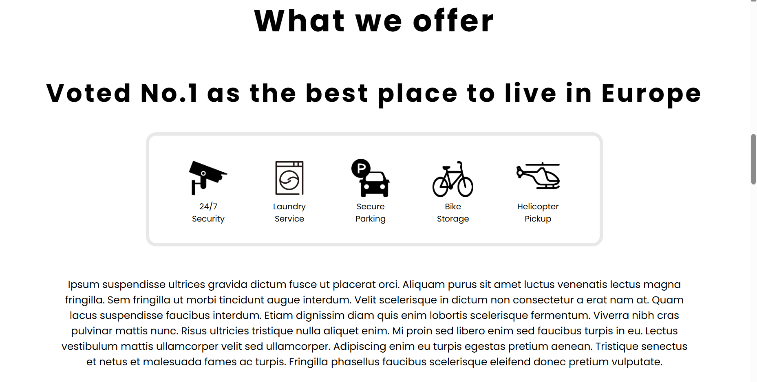**Figure 13.** Benefits section of the location pages

Copied from the main page, this section is beneficial and necessary to all accommodations. Reusing this component saves development time and improves page load time as styling can be reused.

Using the hover CSS selector, when hovered over the subtitle will be enlarged using the “scale ()” method highlighting the information.

**CSS**

.ScrollText:hover{

  transform: scale(1.1);

}

**Figure 14.** Interior image collage within the benefits section of the location pages

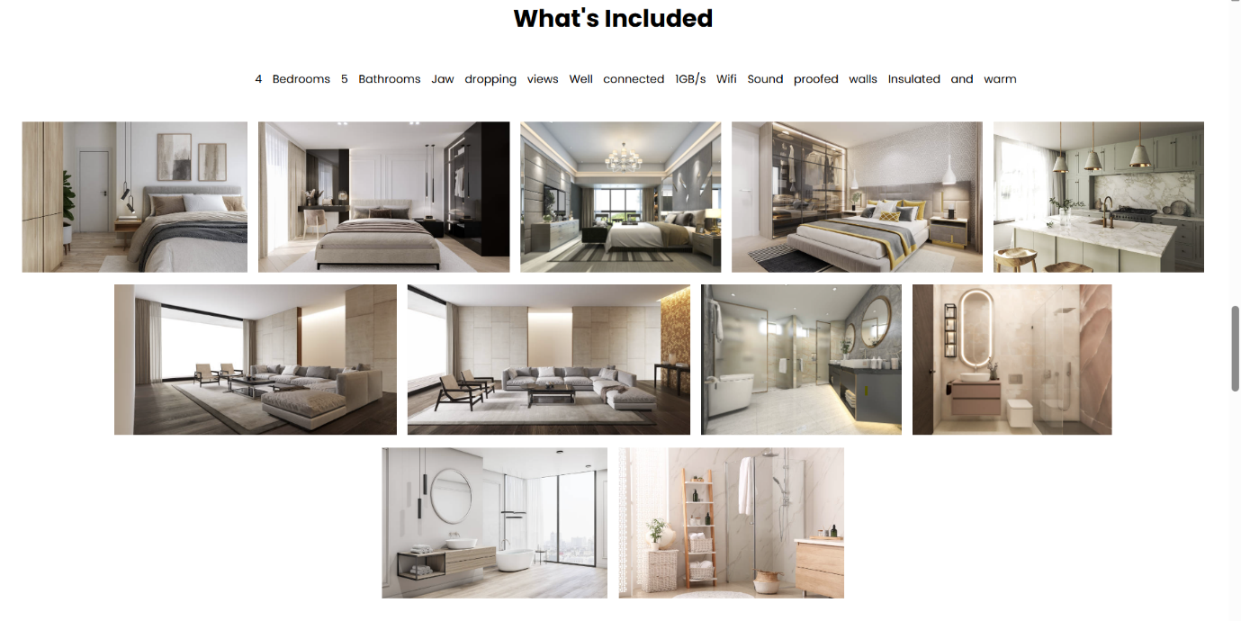

Part of the benefits section, this collage of interior pictures and an inline-styled list details further benefits of the accommodation.

To ensure responsiveness and accessibility, the image collage has a display type of “flex box”. This ensures elements stay within screen width, in this case, elements will become a display type of inline-block as screen width reduces.

**CSS**

.Facilities img{

  display:flex-box;

  padding:5px;

}

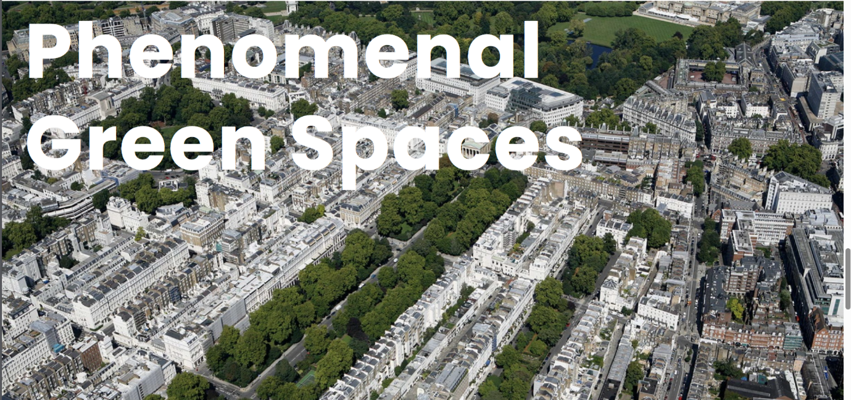**Figure 15.** Hero banner displaying the immediate area of the accommodation

Using the same CSS and HTML as the main page’s hero banner, this section of the page shows an image of the surrounding area.

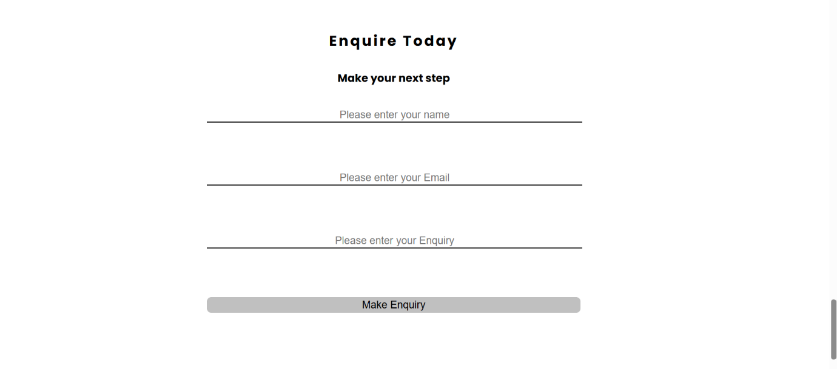**Figure 16.** Enquiry section of the location pages

Using form tags, this enquiry form will take in user data and process it using JavaScript algorithms, the user will receive an email confirmation of their enquiry.

Each input has been spaced, titled and typed, improving readability and ease of use allowing for autofill software.

**HTML**

<form action="">

        <input type = "text" id="inpname" name = "name" placeholder = "Please enter your name">

        <input type = "text" id = "inpemail" name="email" placeholder="Please enter your Email">

        <input type = "text" id = "inpenquiry" name="enquiry" placeholder="Please enter your Enquiry">

        <input id = "submitbutt" type="submit" value="Make Enquiry">

**JavaScript algorithms**

JavaScript plays a key role within the webpage; it is used to handle enquiries responding with an automatic email.

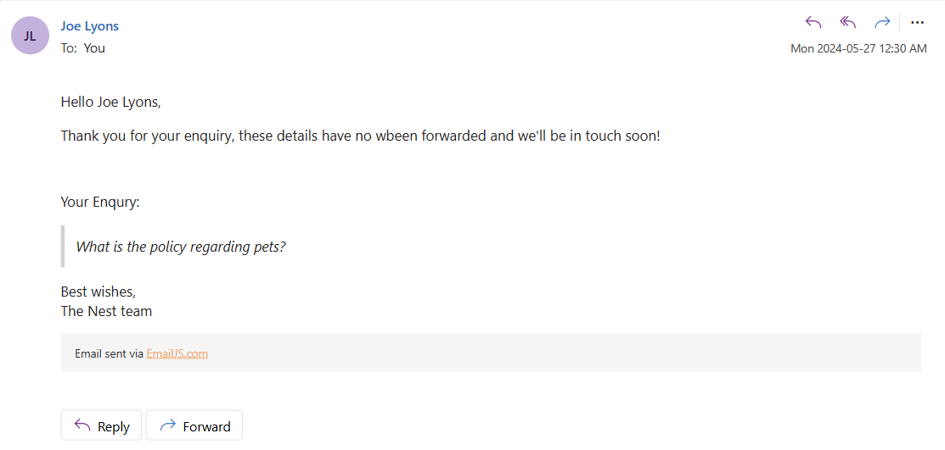**Figure 17.** Email users receive after the enquiry is made.

When the contact button within the main page is clicked, the “openform()” JavaScript function is called. This function edits the page's CSS changing the form elements display type, z-index and the opacity of other page elements, displaying the form.

**JavaScript openform() function**

**function** openform(){

    document.getElementById("EnquireSection").style.display = "block";

    document.getElementById("html").style.opacity = "0.1";

    document.getElementById("EnquireSection").style.opacity = "1";

}

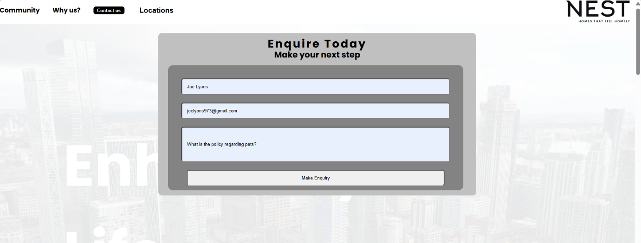**Figure 18.** Enquiry form greeting users after pressing the contact button.

Once submitted, the Javascript “submitform()” function will be called resulting in the “emailjs” API sending an email to the specified email (EmailJS).

**JavaScript submitform() function**

**function** submitform(){

**const** info = document.getElementById("enquire");

**let** name = (info.elements["name"]).value;

**let** email = (info.elements["email"]).value;

**let** enquiry = (info.elements["enquiry"]).value;

    emailjs.send("service_zko5yuh","template_hq7voyf",{

        to_name: name,

        message: enquiry,

        email: email,

        }, "_fC1jhZcfXnMvi2yl").then(

            (response) **=>** {

                alert("Enquiry logged!");

            },

            (error) **=>** {

                alert("Please retry");

            },

        );

}

**Results and Discussion**

**Testing**

**Accessibility testing**

Using browser development tools, the site has been simulated with various dimensions including differing phone dimensions. The site was able to display the information in a clear readable format regardless of dimensions.

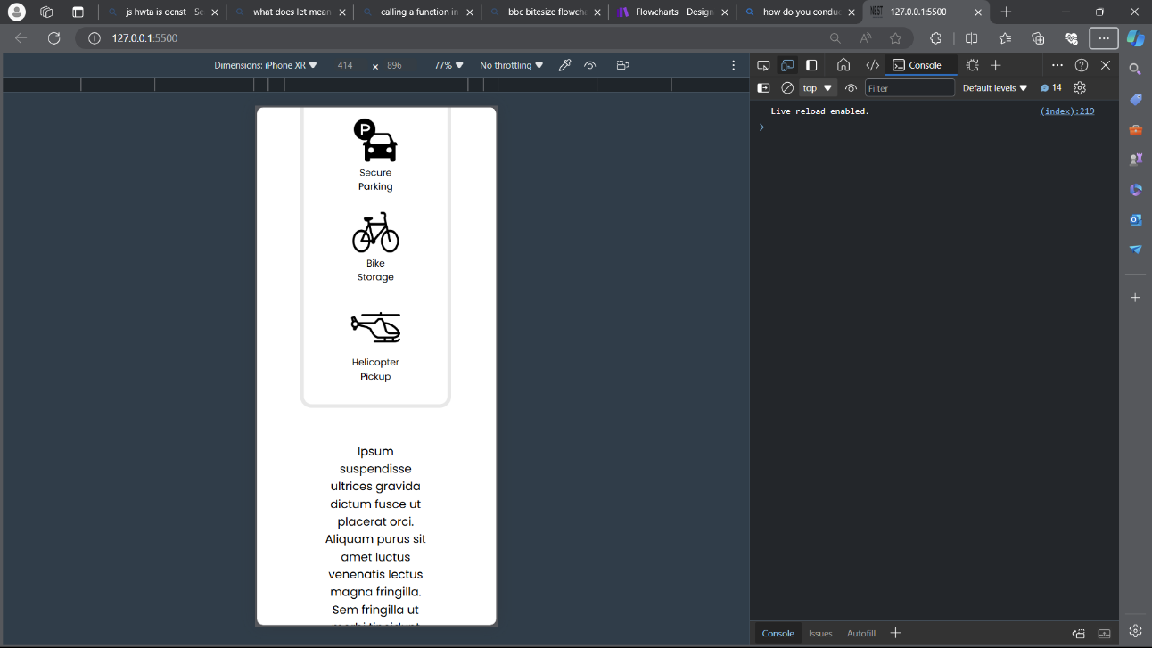**Figure 19.** Accessibility testing using browser tools

**User testing**

|  |  |  |  |
| --- | --- | --- | --- |
| Can differing location pages be accessed? | Yes, all location pages can be easily accessed. | Do all buttons work? | All buttons work as intended. |
| Do all links direct to the intended location? | Yes, all links direct the user to the specific page intended. | Is an email received when an enquiry is logged? | Yes, an email is received as seen in Figure 17. |
| Is data in a clear readable format? | All data can be easily read due to the large-spaced text with key information highlighted. | Can the page size be adjusted without compromising readability | Yes, readability is maintained when adjusting the page size. |

**Conclusion and Further Work**

All aims and objectives have successfully been met and testing has proven the site to be a success. The page has been made responsive, accessible and aesthetically pleasing, it displays all relevant information providing a responsive and interactive user experience. The page can be easily adapted to add further locations and information due to paragraph elements and reused styling.

**Improvements**

The next step for this project could be to integrate chat assistants providing customers with instant support Utilising Artificial Intelligence. Differing themes could also be implemented, such as dark themes, improving readability ease of use and accessibility.

**Reference List**

1. Ceci, L. (2024) *Topic: Mobile internet usage worldwide*, *Statista*. Available at: https://www.statista.com/topics/779/mobile-internet/#topicOverview (Accessed: 30 May 2024).
2. EmailJS (no date) *Overview*, *EmailJS*. Available at: https://www.emailjs.com/docs/tutorial/overview/ (Accessed: 30 May 2024).
3. Hassan, M.M., Ahmad, N. and Hashim, A.H. (2021) ‘Factors influencing housing purchase decision’, *International Journal of Academic Research in Business and Social Sciences*, 11(7). doi:10.6007/ijarbss/v11-i7/10295.
4. Knight, E., Gunawardena, C.N. and Aydin, C.H. (2009) ‘Cultural interpretations of the visual meaning of icons and images used in North American web design’, *Educational Media International*, 46(1), pp. 17–35. doi:10.1080/09523980902781279.
5. Raskin, J. (1994) Viewpoint: Intuitive equals familiar. Communications of the ACM, 37(9), pp.17–18.
6. Statista (2023) *Real estate market in the UK - statistics & facts*. rep. Statista. Available at: https://www.statista.com/topics/6049/real-estate-market-in-the-uk/#topicOverview (Accessed: 29 May 2024).
7. Tullis, T. S., Boynton, J. L. and Hersh, H. (1995) Readability of fonts in the windows environment. Conference 412 companion on Human factors in computing systems - CHI ’95, pp.127–128.
8. Team, N.E. (2021) *12 must-haves for a strong real estate website*, *Nextdoor*. Available at: https://business.nextdoor.com/en-us/blog/10-must-have-features-for-a-strong-real-estate-website#:~:text=%231%20Simple%20navigation%201%20%232%20Advanced%20search%20options,%239%20Internet%20data%20exchange%20integration%20...%20More%20items (Accessed: 30 May 2024).
9. Vardhman, R. (2023) *35+ website Design Industry Statistics: All you need to know in 2024*, *Techjury*. Edited by I. Ivanov. Available at: https://techjury.net/blog/website-design-industry-statistics/#:~:text=There%20are%20only%20about%20200%20million%20active%20websites,70%25%20of%20internet%20traffic%20comes%20from%20mobile%20devices. (Accessed: 30 May 2024).
10. Yadav, P. and Barwal, P.N. (2014) *Designing Responsive Websites Using HTML And  CSS*, 3(11).